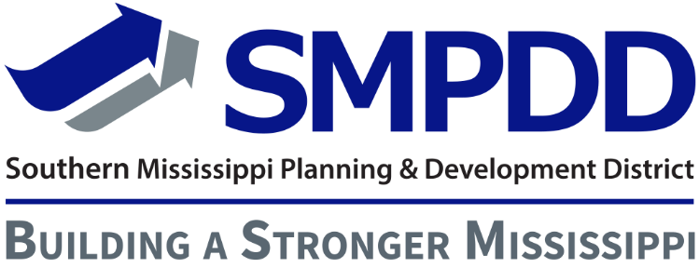

PROGRAM SPECIALIST I JOB DESCRIPTION
General Statement of Duties:
Responsible for the implementation and execution of the Workforce Innovation and Opportunity Act’s (WIOA) Out-of-School youth program objectives. The WIOA Out-of-School Youth Program is designed for youth ages 16-24. The Program Specialist will provide counseling, case management, and coordinate supportive services to eligible youth participants. This part-time position will work in conjunction with the Career Coach.

Responsibilities:
- Conduct outreach and recruitment activities for youth program participants
- Determine eligibility as defined by the WIOA requirements
- Complete participant enrollment, including collection of required documentation
- Maintain participant attendance records, files, and accurate case notes
- Administer Test for Adult Education (TABE)
- Coordinate supportive services that will assist the participant with attendance and participation in program activities and make referrals to partnering agencies as appropriate
- Review all attendance records, work experience timesheets, request for supportive services, and request for incentives for accuracy
- Develop an Individual Service Strategy (ISS) that includes a career pathway for youth participants and update on a regular basis
- Administer objective assessments
- Schedule High School Equivalency testing
- Meet with youth participants on a regular basis to review progress and make adjustments as needed
- Assist in providing academic and job readiness classroom training to youth participants
- Assist in preparing youth for work experience
- Assist in providing instruction on job search skills, resume writing, and interview skills
- Coordinate with the Career Coach and the Job Developer to achieve successful WIOA Youth program outcomes
- Provide follow-up services to exited participants
- Assist youth in accessing advanced training and/or post-secondary education opportunities in selected career pathway
- Maintain confidentiality as it pertains to the WIOA funded youth program and participants
- Perform all other duties as assigned
Knowledge and Skills:
- Excellent interpersonal, verbal, and written communication skills
- Ability to work with a diverse youth population
- Ability to develop plans to aid in personal and career growth
- General knowledge of federally funded job training programs
- Excellent organizational skills
- Ability to multitask
- Proficient computer skills
- Strong ability to problem-solve
- Ability to pay attention to detail
- Ability to work as a team
Education and/or Experience:
- Bachelor’s Degree in Counseling, Education, Social Work, or related field preferred
- Case management experience preferred
- Experience working with out-of-school youth ages 16-24
- Equivalent combinations of education and experience may be considered
Reports to: Youth Program Administrator

SMPDD/TDWDA is an Equal Opportunity Employer/Program. Auxiliary aids and services are available upon request to individuals with disabilities. Those needing TTY assistance may call 800-582-2233.

